Shashank Karthikeyan - Question C2

w)

yt = xt - 0.2xt-1 + 0.7xt-2 🡪 H(z) = 1 – 0.2z-1+0.7z-2

H(z) = 1 – 0.2z-1+0.7z-2 * (z2/z2)

* **H(z) = (z2-0.2 z+0.7)/ z2**

x)

Using Quadratic formula:

**Zeros: 0.1±0.1**\***SQRT(69)j**

y)

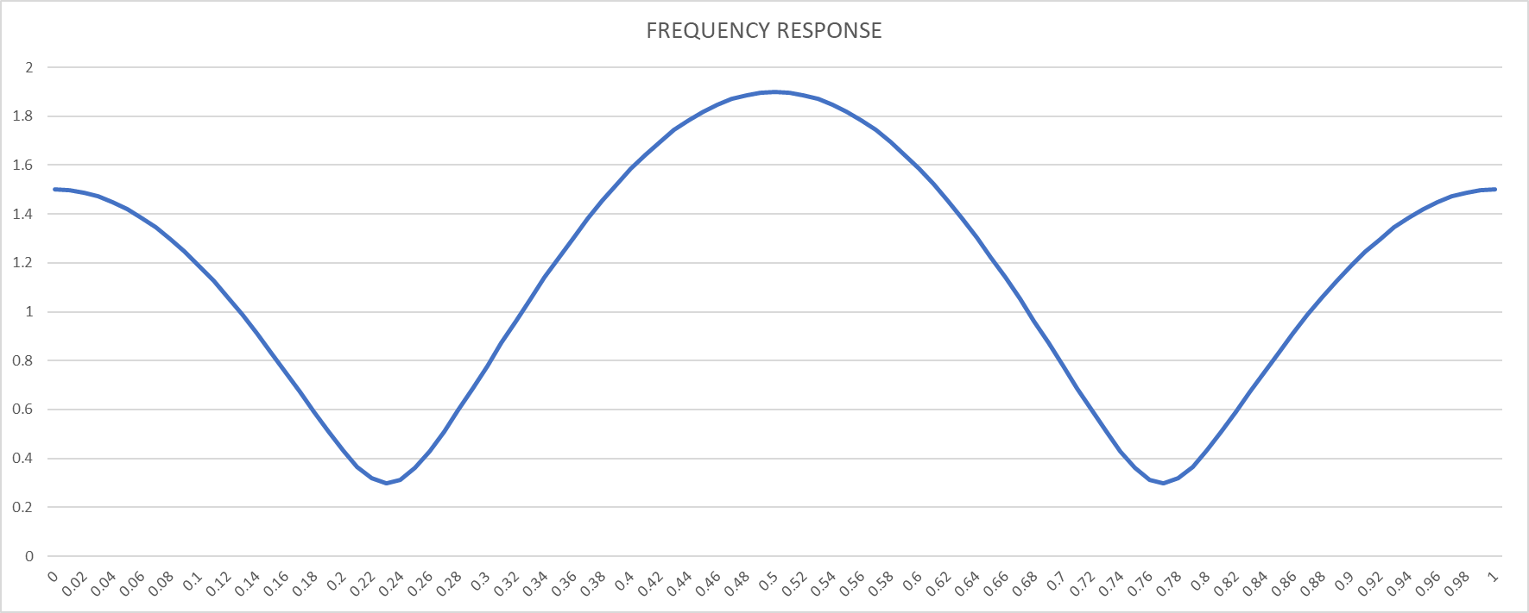

z)

fn = f/fs = 1KHz/32KHz ≈ 0.031

🡪**Gain: 0.872 (According to excel data and graph)**